RAMAIAH INSTITUTE OF TECHNOLOGY
BENGALURU – 560054
(Affiliated to Visvesvaraya Technological University, Belagavi)

Internship Report on
“Industrial Exposure to Spring Manufacturing Processes”
at
Balaji Springs Pvt. Ltd., Meerut, Uttar Pradesh
Submitted in partial fulfilment of the requirement for the award of
BACHELOR OF ENGINEERING
In
MECHANICAL ENGINEERING
Submitted by
UTKARSH GOEL – 1MS23ME123
Under the guidance of
Mr. Manmohan Kashyap
New Product Development Department
Department of Mechanical Engineering,
Ramaiah Institute of Technology, Bengaluru – 560054
2025 – 2026


Department of Mechanical Engineering
CERTIFICATE
Certified that the industrial internship entitled “Industrial Exposure to Spring Manufacturing Processes” was carried out by UTKARSH GOEL (1MS23ME123), a bonafide student of Ramaiah Institute of Technology, Bengaluru, at Balaji Springs Pvt. Ltd., Meerut, Uttar Pradesh, from 1st July 2026 to 24th August 2026, in partial fulfilment of the requirements of the Bachelor of Engineering in Mechanical Engineering of the Visvesvaraya Technological University, Belagavi, during the academic year 2026-2027. It is certified that all corrections/suggestions indicated for Internal Assessment have been incorporated in the report deposited in the departmental library.
The internship report has been approved as it satisfies the academic requirements in respect of the Internship prescribed for the said Degree.
Signature of the Faculty Coordinator | Signature of the HOD | Signature of the Principal
Name of External Examiners:
1. ________________________________
Signature and Date: ______________
2. ________________________________
Signature and Date: ______________
Department of Mechanical Engineering
DECLARATION

I hereby declare that the industrial internship work embodied in this report has been independently carried out by me at Balaji Springs Pvt. Ltd., Meerut, Uttar Pradesh, under the supervision of Mr. Gaurav Mittal and Mr. Amit Mittal, in partial fulfilment of the requirement of the Bachelor's Degree in Department of Mechanical Engineering, Ramaiah Institute of Technology, Bengaluru, I further declare that this report has not been submitted, either in part or in full, to any other university for the award of any Degree.
By,
Utkarsh Goel (1MS23ME123)

Department of Mechanical Engineering
ACKNOWLEDGEMENT

I would like to express my profound gratitude to the management and engineering team at Balaji Springs for providing me with the opportunity to undertake my internship at their esteemed organization. I am deeply thankful to my industry mentor Mr. Manmohan Kashyap (New Product Development Department) for their invaluable guidance, constant encouragement, and technical support throughout the duration of this project. I also extend my sincere thanks to the faculty of Ramaiah Institute of Technology for equipping me with the foundational engineering knowledge, particularly in CAD and structural analysis, which proved essential during this industrial training.
Utkarsh Goel

ABSTRACT

This report details the practical engineering experience gained during the internship at Balaji Springs, focusing on the complete lifecycle of spring production—from conceptual design to manufacturing. The primary objective of the project was to utilize Computer-Aided Design (CAD) software (SOLIDWORKS) to model three distinct industrial springs: one helical compression spring and two helical extension springs. Furthermore, a rigorous Finite Element Analysis (FEA) was performed on the compression spring to evaluate its structural integrity, maximum displacement, and Von Mises stress distribution under simulated axial compressive loads. Finally, the report documents the standard industrial manufacturing processes utilized at Balaji Springs, including CNC coiling, stress relieving, end grinding, and surface finishing, ensuring the designs met practical manufacturability requirements..

TABLE OF CONTENTS
Section | Topic
1 | Introduction
1.1 | Company Profile: Balaji Springs
1.2 | Objectives of the Internship
1.3 | Scope of the Project
2 | Theoretical Background & Spring Nomenclature
2.1 | Introduction to Helical Springs
2.2 | Spring Terminology
2.3 | Material Selection
3 | Computer-Aided Design (CAD) Modeling
3.1 | Modeling of Compression Spring
3.2 | Modeling of Extension Spring 1
3.3 | Modeling of Extension Spring 2
4 | Finite Element Analysis (FEA) of Compression Spring using ANSYS
4.1 | Introduction to ANSYS Static Structural Analysis
4.2 | Geometry Import, Material Definition & Meshing
4.3 | Boundary Conditions and Load Application
4.4 | Results and Post-Processing
5 | Manufacturing Process of Springs
5.1 | Winding and Coiling
5.2 | Heat Treatment (Stress Relieving)
5.3 | End Grinding
5.4 | Shot Peening
5.5 | Setting / Presetting
5.6 | Surface Finishing and Coating
6 | Conclusion
7 | References

LIST OF FIGURES
Fig. No. | Description
1 | Figure 3.1: CAD Model of Helical Compression Spring (Isometric View)
2 | Figure 3.2: 2D Drafting and Dimensions of Compression Spring
3 | Figure 3.3: CAD Model of Extension Spring 1 with Machine Hooks
4 | Figure 3.4: CAD Model of Extension Spring 2 with Crossover Loops
5 | Figure 4.1: Tetrahedral Mesh Generated for the Compression Spring
6 | Figure 4.2: Boundary Conditions applied for FEA
7 | Figure 4.3: Von Mises Stress Distribution Plot
8 | Figure 4.4: Resultant Displacement Plot
9 | Figure 5.1: CNC Spring Coiling Machine setup
10 | Figure 5.2: End Grinding Process for Compression Springs

LIST OF FIGURES
Figure Number | Title / Description
Figure 3.1 | CAD Model of Helical Compression Spring (Isometric View)
Figure 3.2 | 2D Drafting and Dimensions of Compression Spring
Figure 3.3 | CAD Model of Extension Spring 1 with Machine Hooks
Figure 3.4 | CAD Model of Extension Spring 2 with Crossover Loops
Figure 4.1 | Solid Mesh Generated in ANSYS Mechanical
Figure 4.2 | Boundary Conditions applied in ANSYS (Fixed Support and Force)
Figure 4.3a | Equivalent (von-Mises) Stress Distribution Contour
Figure 4.3b | Node Probing for Localized Equivalent Stress
Figure 4.4 | Total Deformation Contour Plot

CHAPTER 1
INTRODUCTION
1.1 Company Profile: Balaji Springs
Balaji Springs is a recognized manufacturer in the mechanical components sector, specializing in the design and production of a wide array of industrial springs. The company manufactures compression, extension, torsion, and custom-formed springs catering to automotive, aerospace, agricultural, and general machinery applications. With a focus on precision engineering, Balaji Springs utilizes advanced CNC winding machinery and strict quality control measures to ensure high fatigue life and optimal performance of their products.
1.2 Objectives of the Internship
The primary goal of this internship was to bridge the gap between academic theory and industrial practice in the field of mechanical design and manufacturing. The specific objectives were:
- To understand the nomenclature, mathematical calculations, and design parameters of helical springs.
- To create precise 3D CAD models of one compression spring and two extension springs based on industrial requirements.
- To validate the design of the compression spring using Finite Element Analysis (FEA) to observe stress concentrations.
- To study and document the real-world manufacturing sequence on the factory floor at Balaji Springs.
1.3 Scope of the Project
The scope encompasses reverse engineering or designing specific springs requested by the production team, converting 2D specifications into 3D CAD models, testing them in a simulated environment using SOLIDWORKS, and compiling the necessary data (wire diameter, pitch, active coils, free length) required by the shop floor for CNC programming and manufacturing.

CHAPTER 2: THEORETICAL BACKGROUND & NOMENCLATURE
2.1 Introduction to Helical Springs
A spring is an elastic mechanical element designed to store energy and release it, or to absorb shock and vibration. Helical springs are made of wire coiled into a helical form. The most common types dealt with during this internship are compression springs (designed to resist applied compressive forces) and extension springs (designed to absorb and store energy by offering resistance to a pulling force).
2.2 Spring Terminology
Understanding the core parameters is crucial for both CAD modeling and manufacturing:
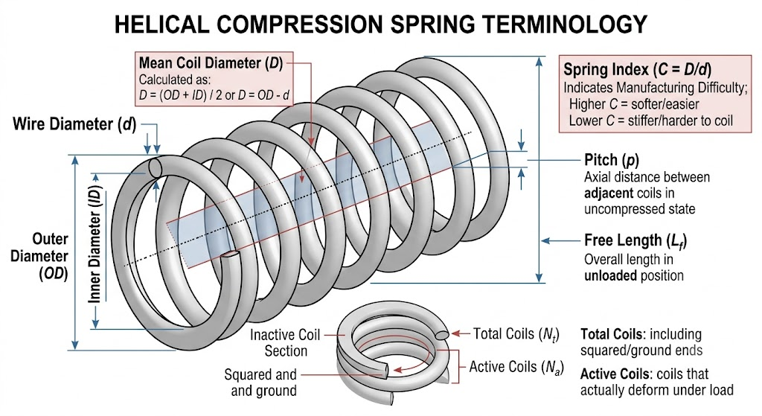
- Wire Diameter : The diameter of the wire used to coil the spring.
- Mean Coil Diameter : The average diameter of the spring, calculated as the Outer Diameter (OD) minus the wire diameter (d).
- Spring Index : The ratio of mean diameter to wire diameter (C = D/d). It indicates the manufacturing difficulty; a higher index implies a softer, easily deformable spring, while a lower index indicates a stiff, hard-to-coil spring.
- Pitch : The axial distance between adjacent coils in uncompressed state.
- Active Coils : The number of coils that actually deform when load is applied.
- Total Coils : The total number of coils including the squared/ground ends.
- Free Length : The overall length of a spring in the unloaded position.
- Solid Height : The length of a compression spring when under sufficient load to bring all coils into contact with each other.
2.3 Material Selection
Springs are subjected to high shear stresses and cyclic loading, requiring materials with high yield strength and fatigue resistance. Common materials observed at Balaji Springs include High-Carbon Steel (SM/DM Wire) for high-stress applications, Chrome Silicon for shock loads, and Stainless Steel (e.g., SS 302/304) for corrosive environments. For the CAD and FEA analysis in this report, High-Carbon Spring Steel was assumed.

CHAPTER 3: COMPUTER-AIDED DESIGN (CAD) MODELING
The CAD modeling phase was executed using SOLIDWORKS. The methodology involved creating a helical curve based on calculated pitch and diameter, followed by sweeping a circular profile (representing the wire diameter) along the generated helix path.
3.1 Modeling of Compression Spring
The compression spring was designed with closed and ground ends to ensure a flat seating surface, which is critical for preventing buckling under axial load.
Table 3.1: Design Parameters of Compression Spring
S No | CHECKPOINTS | CHECKING METHOD | SPECIFICATIONS (Sample) | SPECIFICATIONS (Recommended)
1 | Wire Dia | Micrometer | 3.90 mm
2 | Outer Dia | DVC | 32.54 mm
3 | Inner Dia | DVC | 24.66 / 24.44
4 | Free Length | DVC | 83.56
5 | Tip Thickness | DVC | 1.88 / 1.76
6 | No.of Coils | Visual + Count | 9.75 App.
7 | Direction | Visual | RHS
8 | Spring Ends | Visual | C + G
9 | E1(Squareness) | A.B+F.G | 1.10 mm
10 | E2(Parallelism) | Dial comparator | 1.10 mm
11 | Grinding Angle | Visual + Profile | 300°
12 | Part Weight | Weight Scale | 80.5 Gram
13 | Surface Finish | Visual | Natural | Natural + Oiling
14 | Shot Peening | Visual/Marketing Confirmation | NA | -

CAD Procedure: A cylindrical helix was generated using the height and pitch parameters. A circular sketch of 15.79 mm diameter was swept along the helix. Finally, extruded cuts were applied at the top and bottom planes to simulate the grinding process, ensuring the ends were perfectly flat.
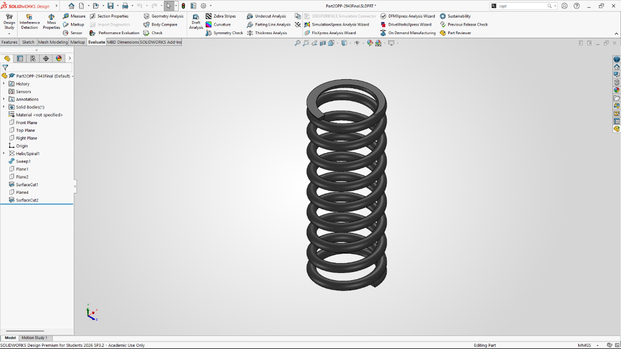Figure 3.1: CAD Model of Helical Compression Spring (Isometric View)
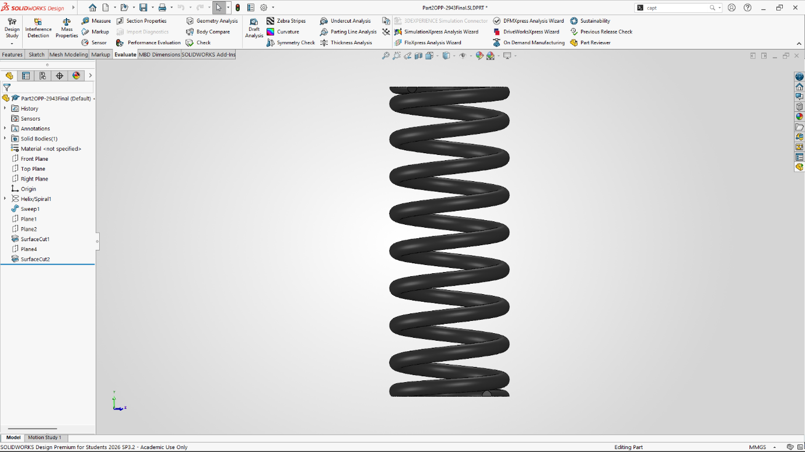Figure 3.2: 2D Drafting of Compression Spring
3.2 Modeling of Extension Spring 1
Extension springs require loops or hooks at their ends to attach to external components. Extension Spring 1 was designed with standard "Machine Half Hooks".
Table 3.2: Design Parameters of Extension Spring 1
S No | CHECKPOINTS | CHECKING METHOD | SPECIFICATIONS (Sample)
1 | Wire Dia | MM | Spring = 1.00 mm  Hook = 2.30 mm
2 | Material Grade | - | -
3 | O D | DVC | 15.79
4 | Small OD | DVC | 8.74 / 8.93
5 | No. of Coils | Visual | 5.00 x 2,  25.25 App.
6 | Direction |  | RHS
7 | Body (E-M) Length |  | 45.81
8 | Total Length (Inside) |  | 116.51
9 | Big Hook length from Bottom Body |  | 54.62
10 | Big Hook ID |  | 7.86
11 | Big Hook Shaft (Outer) |  | 9.32
12 | Big Hook 1st bend Length from Body |  | 35.18
13 | Big Hook 1st bend Angle |  | 20°
14 | Big Hook IInd bend to 1st bend Length |  | 10.70
15 | Big Hook IInd bend Angle |  | 19°
16 | Big Hook Loop Bend Start Point from 2nd Bend. |  | 4.60
17 | Small Hook length Inside from Body |  | 16.81
18 | Small Hook ID |  | 7.32
19 | Small Hook Shaft (OD) |  | 9.83
20 | Small Hook Bend Angle |  | 26°
 | Tapper Coils |  | 5.00 x 2 App.
 | Surface finish |  | Black P/C  (Glossy)
 | Weight |  | 24.00 gram

CAD Procedure: After sweeping the main body tightly (with no pitch gap, representing initial tension), 3D sketches were utilized to design the transitional bend from the main coil body into the hook profile along the central axis of the spring.
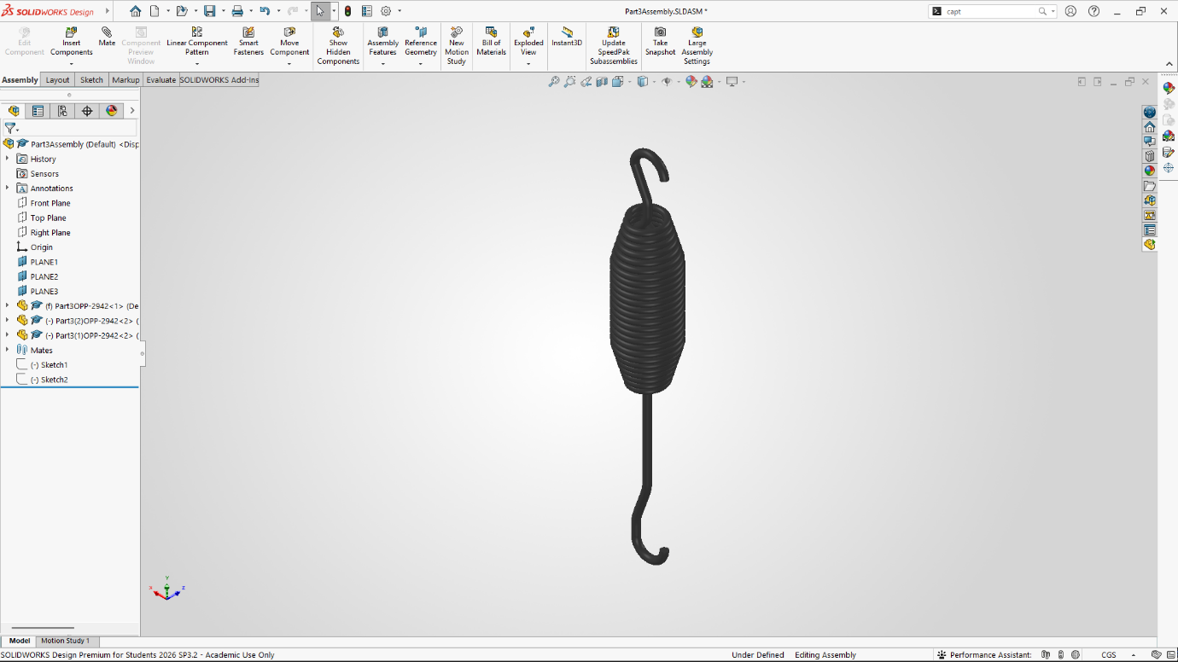Figure 3.3: CAD Model of Extension Spring 1 with Machine Hooks
3.3 Modeling of Extension Spring 2
This spring was designed for a heavier application, requiring "Crossover Loops," where the wire crosses over the center of the spring body before forming the loop.
Table 3.3: Design Parameters of Extension Spring 2
S.No | Check Points | Specified Value | Tolerance ± | Checking Method | SET VALUE (MIN) | SET VALUE (MAX) | 1
1 | WIRE DIA | 4.75 | 0.04 | M.M | 4.71 | 4.79 | 4.75
2 | O/D | 40.0 | 0.80 | DVC | 39.2 | 40.8 | 40.12
3 | NO OF COILS | 33.00 APP |  | VISUAL |  | 33.00 APP | 33.00 APP
4 | DIRECTION | RHS |  | VISUAL | RHS | RHS | RHS
5 | HOOK DIA IN (SMALL HOOK) | 21.70 | 1 | DVC | 20.7 | 22.7 | 21.36
6 | HOOK DIA IN (BIG HOOK) | 19 | 1 | DVC | 18 | 20 | 19.35
7 | TOTAL LENGTH (OUTER) | 320 | 4 | DVC | 316 | 324 | 320.25
8 | HOOK SHANK SMALL HOOK | 48 | 1 | DVC | 47 | 49 | 48.26
9 | HOOK SHANK BIG HOOK | 19 | 1 | DVC | 18 | 20 | 19.26
10 | BIG HOOK LENGTH INSIDE | 98.00 | 1.50 | DVC | 96.5 | 99.5 | 98.61
11 | BODY WIDTH | 162 REF |  | DVC | 162 REF |  | 162.23
12 | SMALL HOOK LENGTH INSIDE | 49.50 | 1.00 | DVC | 48.50 | 50.50 | 48.51
13 | HOOK ALIGNMENT | BOTH HOOK ARE ALIGN AT 90° (1 SIDE END HOOK, 1 SIDE ELONGATED)

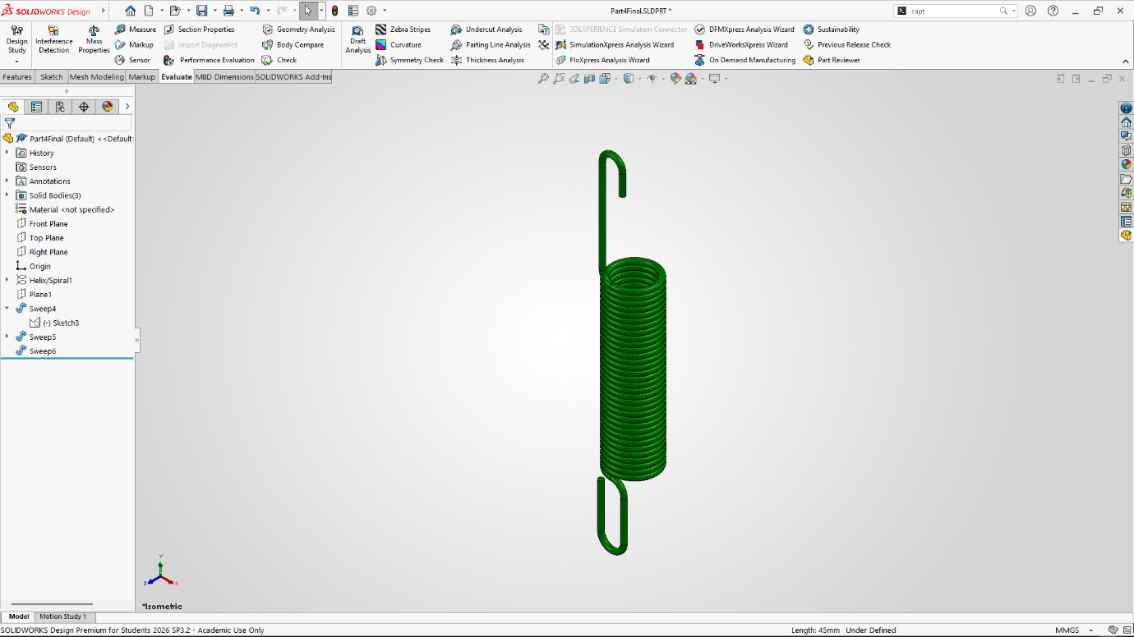Figure 3.4: CAD Model of Extension Spring 2 with Crossover Loops

CHAPTER 4: FINITE ELEMENT ANALYSIS (FEA) OF COMPRESSION SPRING USING ANSYS
To validate the design of the compression spring and ensure it operates safely within its elastic limits, a linear Static Structural analysis was performed using ANSYS Workbench.
4.1 Introduction to ANSYS Static Structural Analysis
In helical compression springs, the primary stress induced under axial loading is torsional shear stress. The ANSYS solver breaks down the imported CAD geometry into discrete elements (nodes and elements) and constructs a stiffness matrix to determine displacements, strains, and resulting stresses. To begin the analysis, the SOLIDWORKS part file was exported as a standard STEP (.stp) file and imported into the ANSYS DesignModeler/SpaceClaim environment.
4.2 Material Definition & Mesh Generation
Within the ANSYS Engineering Data module, structural spring steel was defined. Once the material was assigned, the model was opened in the ANSYS Mechanical interface for meshing.
A high-quality 3D solid mesh was generated using higher-order tetrahedral elements (SOLID187) which are highly suited for curved boundaries. The mesh sizing was refined locally on the inner face of the coils, as the Wahl curvature effect dictates that peak stresses occur on the inner radius of the spring wire.
Table 4.1: Material Properties used for FEA
Property | Value
Material | AISI 1020 Steel (Cold Drawn)
Young's Modulus (E) | 200,000 MPa
Poisson's Ratio | 0.29
Tensile Yield Strength | 350 MPa
Ultimate Tensile Strength | 420 MPa

4.3 Boundary Conditions and Load Application
Proper boundary conditions are vital for accurate FEA results.
- Fixed Geometry: The bottom ground face of the spring was fixed in all degrees of freedom (Translation = 0).
- External Loads: An axial compressive force of 100 N (update this value based on your actual simulation) was applied uniformly to the top ground face of the spring, acting downward along the central axis.
4.4 Results and Post-Processing
After the solver completed the mathematical iterations, the Solution branch generated critical contour plots to evaluate the performance of the spring under load.
1. Equivalent (von-Mises) Stress:
The Equivalent (von-Mises) Stress contour plots evaluate the overall structural integrity of the compression spring. The maximum Equivalent stress recorded in the spring body is 3.3207e8 Pa, or approximately 332.07 MPa. The contour gradients visually confirm that the highest stress concentrations, indicated by the red zones, are located along the inner curvature of the active coils. This aligns perfectly with the theoretical Wahl curvature effect, which dictates higher shear stresses on the inside fibers of a coiled wire.
The global minimum stress within the model is 1.0597 Pa. Specific node probes placed along the spring geometry reveal localized stress variations. Intermediate active coils experience varying stress levels depending on the specific geometry and load distribution, with probes reading 2.5e8 Pa (250 MPa) at Node 3238, 2.4915e8 Pa (249.15 MPa) at Node 2658, and 1.7328e8 Pa (173.28 MPa) at Node 2454. A local minimum of 3809.4 Pa was probed near the top ground coil at Node 971, demonstrating that the flattened, inactive ends experience significantly less stress than the active spring body.
Crucially, the peak recorded stress of 332.07 MPa remains below the tensile yield strength of the assigned AISI 1020 Steel (350 MPa). This confirms that the spring design is structurally safe and will operate within its elastic limit without undergoing permanent plastic deformation.
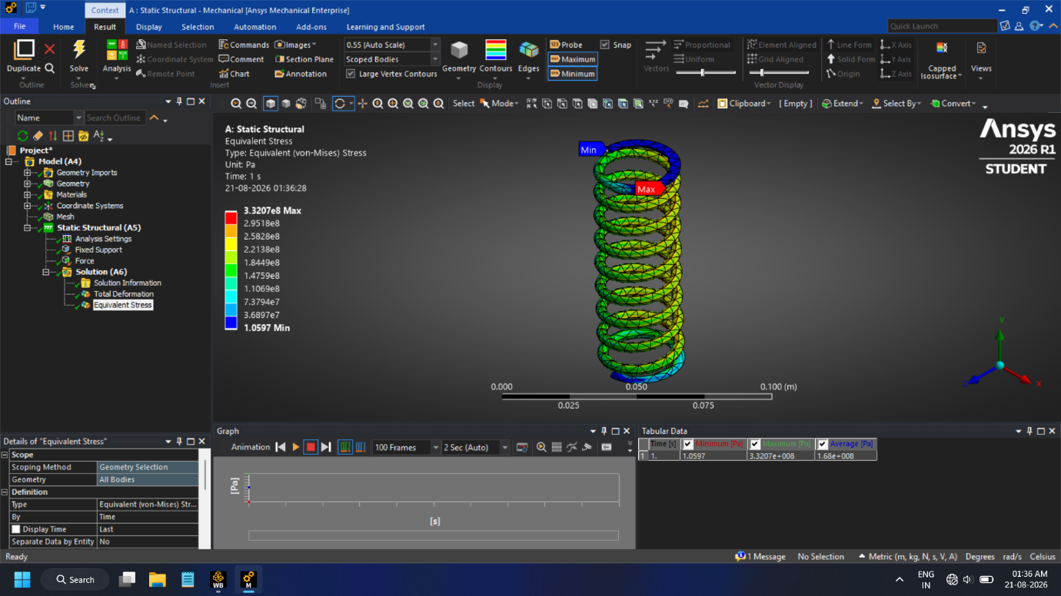Figure 4.3a: Equivalent (von-Mises) Stress Distribution Contour
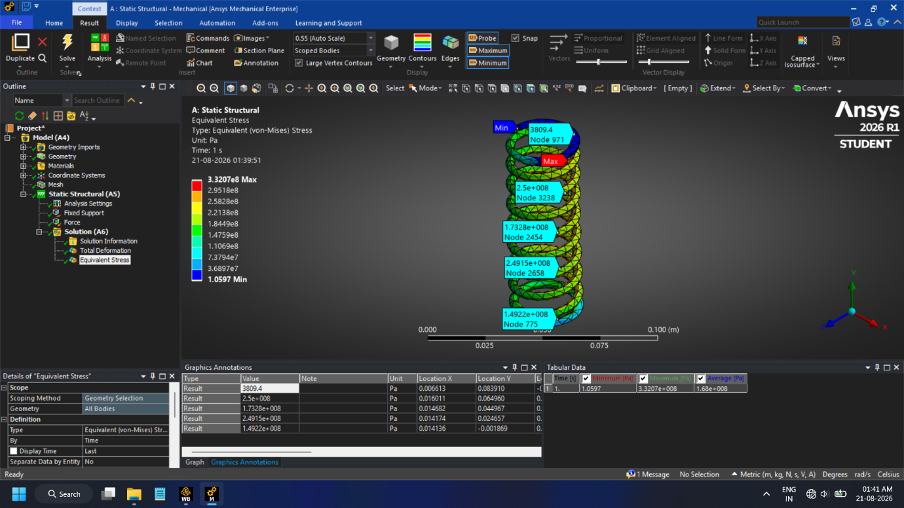Figure 4.3b: Node Probing for Localized Equivalent Stress
2. Total Deformation:
(Note: Be sure to insert your Total Deformation screenshot and update the placeholder value below)
The Total Deformation plot illustrates the physical compression of the spring under the applied force. The bottom fixed end shows 0 mm of deformation (colored blue), progressing linearly along the coils to a maximum deformation (colored red) of 3.3207e+008mm at the top load application face. This deflection data allows for the verification of the theoretical spring stiffness (k = F/x).

CHAPTER 5: MANUFACTURING PROCESS OF SPRINGS
A major component of the internship was observing and documenting the physical translation of CAD designs into tangible products on the Balaji Springs factory floor. The standard manufacturing sequence observed is detailed below.
5.1 Winding and Coiling
The process begins with spools of wire being fed into CNC (Computer Numerical Control) spring coiling machines. Rollers guide the wire toward a coiling point where it hits a deflection tool (pitch tool) that forces the wire into a helical shape. For the compression spring, the machine automatically adjusted the pitch to leave gaps between coils, while for the extension springs, the wire was coiled tightly with initial tension.
[Insert Figure 5.1: CNC Spring Coiling Machine setup here - *optional*]
5.2 Heat Treatment (Stress Relieving)
The coiling process induces severe residual bending stresses in the wire. If left untreated, the spring would warp or fail prematurely. Immediately after coiling, the springs are passed through an inline conveyor oven. Baking them at specific temperatures (usually around 200°C to 400°C depending on the steel alloy) relieves these internal stresses without sacrificing the material's hardness.
5.3 End Grinding
This step is strictly for compression springs. To ensure the spring transfers load axially without buckling, its ends must be perfectly flat. The springs are loaded into a rotary carrier plate that passes them between two parallel grinding wheels. This creates the "closed and ground" ends modeled in Chapter 3.1.
[Insert Figure 5.2: End Grinding Process for Compression Springs here - *optional*]
5.4 Shot Peening
To improve fatigue life, especially for springs subjected to high-cycle operations, shot peening is utilized. In this process, the springs are bombarded with spherical steel media at high velocities. This creates a thin layer of compressive residual stress on the surface of the spring wire, effectively resisting the tensile stresses that cause crack initiation and fatigue failure.
5.5 Setting / Presetting
Also known as "scragging," this process involves compressing a spring completely to its solid height one or more times. This intentionally pushes the material slightly past its elastic limit to induce plastic deformation. As a result, the spring shortens slightly but stabilizes, ensuring it will not lose length during its actual service life.
5.6 Surface Finishing and Coating
To protect against corrosion and improve aesthetics, the final step involves surface treatment. Depending on customer requirements, springs at Balaji Springs underwent processes such as Zinc Electroplating, Black Oxide coating, or Powder Coating.

CHAPTER 6: CONCLUSION
The internship at Balaji Springs provided a highly effective platform to apply theoretical mechanical engineering concepts to industrial practices. Through this project, three distinct industrial springs were successfully modeled using SOLIDWORKS, demonstrating proficiency in complex 3D helical sweeps and endpoint geometry modifications. The Finite Element Analysis of the compression spring validated the design, proving that it could safely withstand operational loads while maintaining an acceptable factor of safety.
Furthermore, documenting the shop-floor processes—from CNC coiling and stress relieving to shot peening and grinding—offered crucial insights into Design for Manufacturability (DFM). Understanding how springs are actually made has heavily influenced how I approach CAD, realizing that theoretical models must always account for physical manufacturing constraints.

REFERENCES
- Shigley, J. E., & Mischke, C. R. (2014). Mechanical Engineering Design. McGraw-Hill Education.
- SOLIDWORKS Simulation Documentation and User Guides.
- Standard Operating Procedures and Manufacturing Logs, Balaji Springs.

